

[Document title]

[Document subtitle]



Table of Contents

Table of Contents 2

Executive Summary 3

Objectives 4

Team Selection 4

Economic Impact 6

Revenue Growth Analysis and Projection 6

Expense Growth Analysis and Projection 7

Impact on GDP 9

Impact on Related Industry 10

Impact on Rarita provinces 11

Implementation plan 11

Team selection 11

Players' Salary Cost 12

Sources of Revenue 13

Assumptions 14

Risk & Sensitivity Analysis 15

Risk identification & Mitigation 15

Quantitative Risk Management 17

Revenue Sensitivity Analysis 17

Investment Portfolio Sensitivity Analysis 18

Data & Data Limitations 19

Appendix 20

R Code 20

Categorization of Countries for 3.3 impacts on GDP 26

Works Cited 27

# Executive Summary

Our team, Scout Cookies, has been hired by The Commission of Sport in Rarita to provide comprehensive business strategies. We design a national soccer team construction plan that will build a brand for Rarita’s football program and benefit economically. This program involves the implementation of a newly founded soccer team with yearly generating revenue and economic impact.

Several assumptions are made before we start building up the team. Several statistical learning methods are applied, and K-Nearest Neighbors (KNN) is the most effective to perform players selection. Over 20 countries are grouped into 3 groups by their competition performance indicators. With different growth rates under different scenarios, we apply Scenario analysis and regression analysis in finance projection and economic indices forecasting in the next decade. Qualitative and quantitative risks are illustrated using the descriptive images and Monte-Carlo simulations method.

Under the program outlined above, we expect that the soccer team qualifies for the international FSA league within the next 5 years and highly possible to achieve an FSA championship within the next 10 years. 19 players are selected finally based on their performance and team fit. The program is also projected to generate at least total revenue of ∂ 2415.57 per capita over the next decade. Because of the visibility and dynamics brought by the national soccer team, the GDP of Rarita will expected to have relatively high growth in the next decade.

# Objectives

In order to achieve financial benefits by receiving direct rewards of high performance and boosting relevant industries by promoting soccer national-wide, Rarita decides to initiate a project to form a national soccer team with top players. The national team aims to rank as seasonal top ten members within the next five years and have high chances of achieving an FSA championship within the next 10 years.

The objective of this case study is to construct a competitive national soccer team using multiple statistical learning methods. Upon the team formation, a solid and comprehensive implementation plan is composed. The corresponding economic impact is analyzed based on the implementation plan. Supported by thorough research and quantitative analysis, robust risk analysis is performed to mitigate foreseeable risks and provide a well-round foundation to serve the purposes.

# Team Selection

We assume that a competitive team consists of players with the same level of skills as those in the successful teams in the past two years. Therefore, we use the K-Nearest Neighbours (KNN) algorithm to select players as it is particularly good for solving classification problems.

To select non-goalkeeper players (i.e. forwards, midfielders and defenders), the shooting table, passing table and defense table are inner-joined together by players. The missing values are assigned to 0 since all the relevant attributes have very small (close to 0) values. We also notice that both the 2020 and 2021 data are given for a player and players might change teams mid-season. To avoid inconsistency in the players’ performance over time, multiple entries of a player in the league data and tournament data are combined and averaged to a single record, respectively. The goalkeeper data is formatted in a similar way except that it does not require joining tables.

There are 60 attributes in the combined table and a lot of them are correlated. To simplify the model and reduce multicollinearity, we decide to use Principal Component Analysis (PCA) for dimension reduction. The followings are the plot of the eigenvalues of the correlation matrix and the plot of the variation explained vs the number of the components.

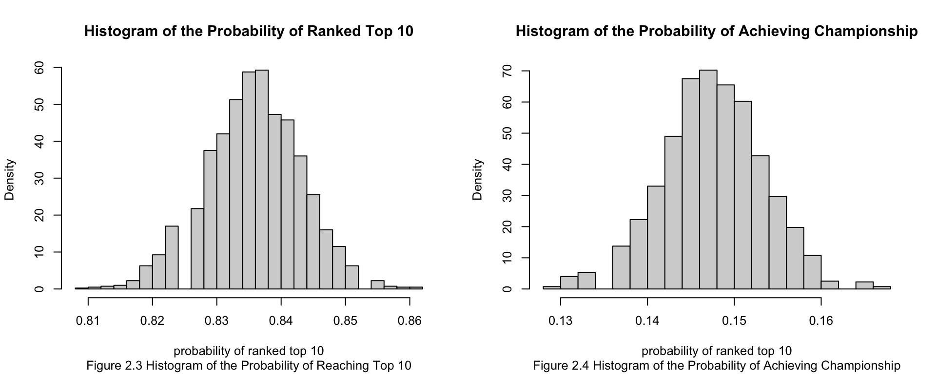

Figure 2.1 shows a clear exponential decreasing trend in the eigenvalues and Figure 2.2 shows that 90% of the variations are explained using 21 components. Therefore, we perform PCA to reduce the data to 21 independent components.

We then apply the KNN algorithm to compare each player in the league dataset with the players in the tournament dataset and use the average ranking of the k most similar players in the tournament as the predictive ranking for that player. After that, 19 players are manually selected from the pool of 64 players with predictive rank 1 (i.e. the players that closely reassemble a championship team) based on their positions, salaries, age, popularities and nationalities. The tuning variable k in the KNN algorithm is selected using cross-validation on the tournament data that leads to the highest accuracy rate given an error threshold. After running the algorithm 1000 times, we can obtain an average accuracy rate of 84.4% and 14.7% when we set the error threshold to 9 and 0 correspondingly. This means that the selected team (whose players all have predictive rank 1) will on average have an 84% probability to rank within the top ten members of the FSA and 14.7% probability to achieve championships. Here are the histograms of the corresponding accuracy rates.

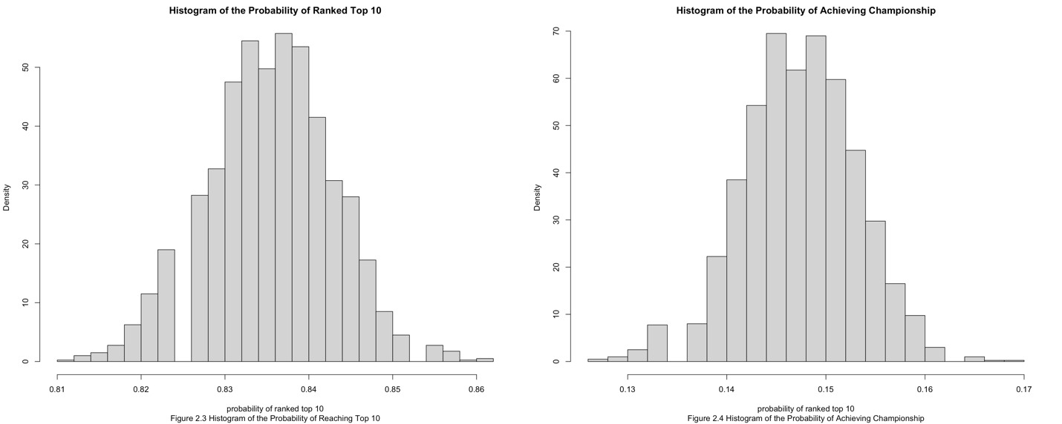

The plots show clear normality. Therefore, using $μ±z∙SD$, we are 95% confident that the team will have a probability of 82% to 84.9% of ranking top 10 and a probability of 13.5% to 16% of reaching the championship.

# Economic Impact

## Revenue Growth Analysis and Projection

Based on assumptions (in the “Assumption” Section), we conduct the scenario analysis for all the countries in 2021 Tournament Ranking and categorize them into three different clusters by using the competition ranking of 2021 Tournament Ranking, Attendance Ranking and Social Media Followers Ranking.

$$Annualized Growth Rate={\frac{Revenue in Year 2020}{Revenue in Year 2016}}^{0.25}-1$$

The average annualized growth rate shows a slowdown in the “developed group” (0.22%), whereas in the “developing group” it indicates a high growth (7.10%). In the matchday revenue and broadcasting revenue parts, the “developed group” even shows a negative growth rate (-4.19% and -0.26%), while the “developing group” remains high growth. Intuitively, when a team achieves the top ranking, its revenue will increase but the growth rate would decrease with a larger base value; The new starters, are expected to have larger potential in growth than the top-ranking teams.

*****Figure 3.1 Average revenue growth rates from 2016-2020 in different groups*

*\*

The revenues for the next ten years are forecasted with the growth rates above.

$$Revenue Forecast in Year \left(N+1\right)=Revenue in Year N*\left(1+Growth Rate\right)$$

**

*Figure 3.2 Revenue projection of Rarita in future 10 years: 2021-2030 based on growth rates of each part (2021 - 2024 follows “developing case”, 2025-2027 follows “elementary case”, 2028-2030 follows “developed case”)*

## Expense Growth Analysis and Projection

Annualized total growth rates of expense follow the same pattern as revenue. The annualized growth rates of the “negative group” are higher than the rates of the “positive group”.



$$Annualized Growth Rate={\frac{Expense in Year 2020}{Expense in Year 2016}}^{0.25}-1$$

*Figure 3.3 Average expense growth rate from 2016-2020 in different groups*

The revenues for the next ten years are forecasted with the growth rates above.

$$Expense Forecast in Year \left(N+1\right)=Expense in Year N*\left(1+Growth Rate\right)$$



*Figure 3.4 Expense projection of Rarita in future 10 years: 2021-2030 based on growth rates of each part (2021 - 2024 follows “developing case”, 2025-2027 follows “elementary case”, 2028-2030 follows “developed case”)*

For detailed sources of revenue and usage of expenses, please refer to “Implementation Plan” part.

## Impact on GDP

For GDP prediction, we use the same method as projecting Revenue and Cost.



A team's annual growth rate of GDP per capita is highest when it performs mid-pack. High performing teams can simply achieve saturation. These teams' growth potential is restricted, as is the expansion of related industries, which can result in a limited multiplier effect. 

## Impact on Related Industry

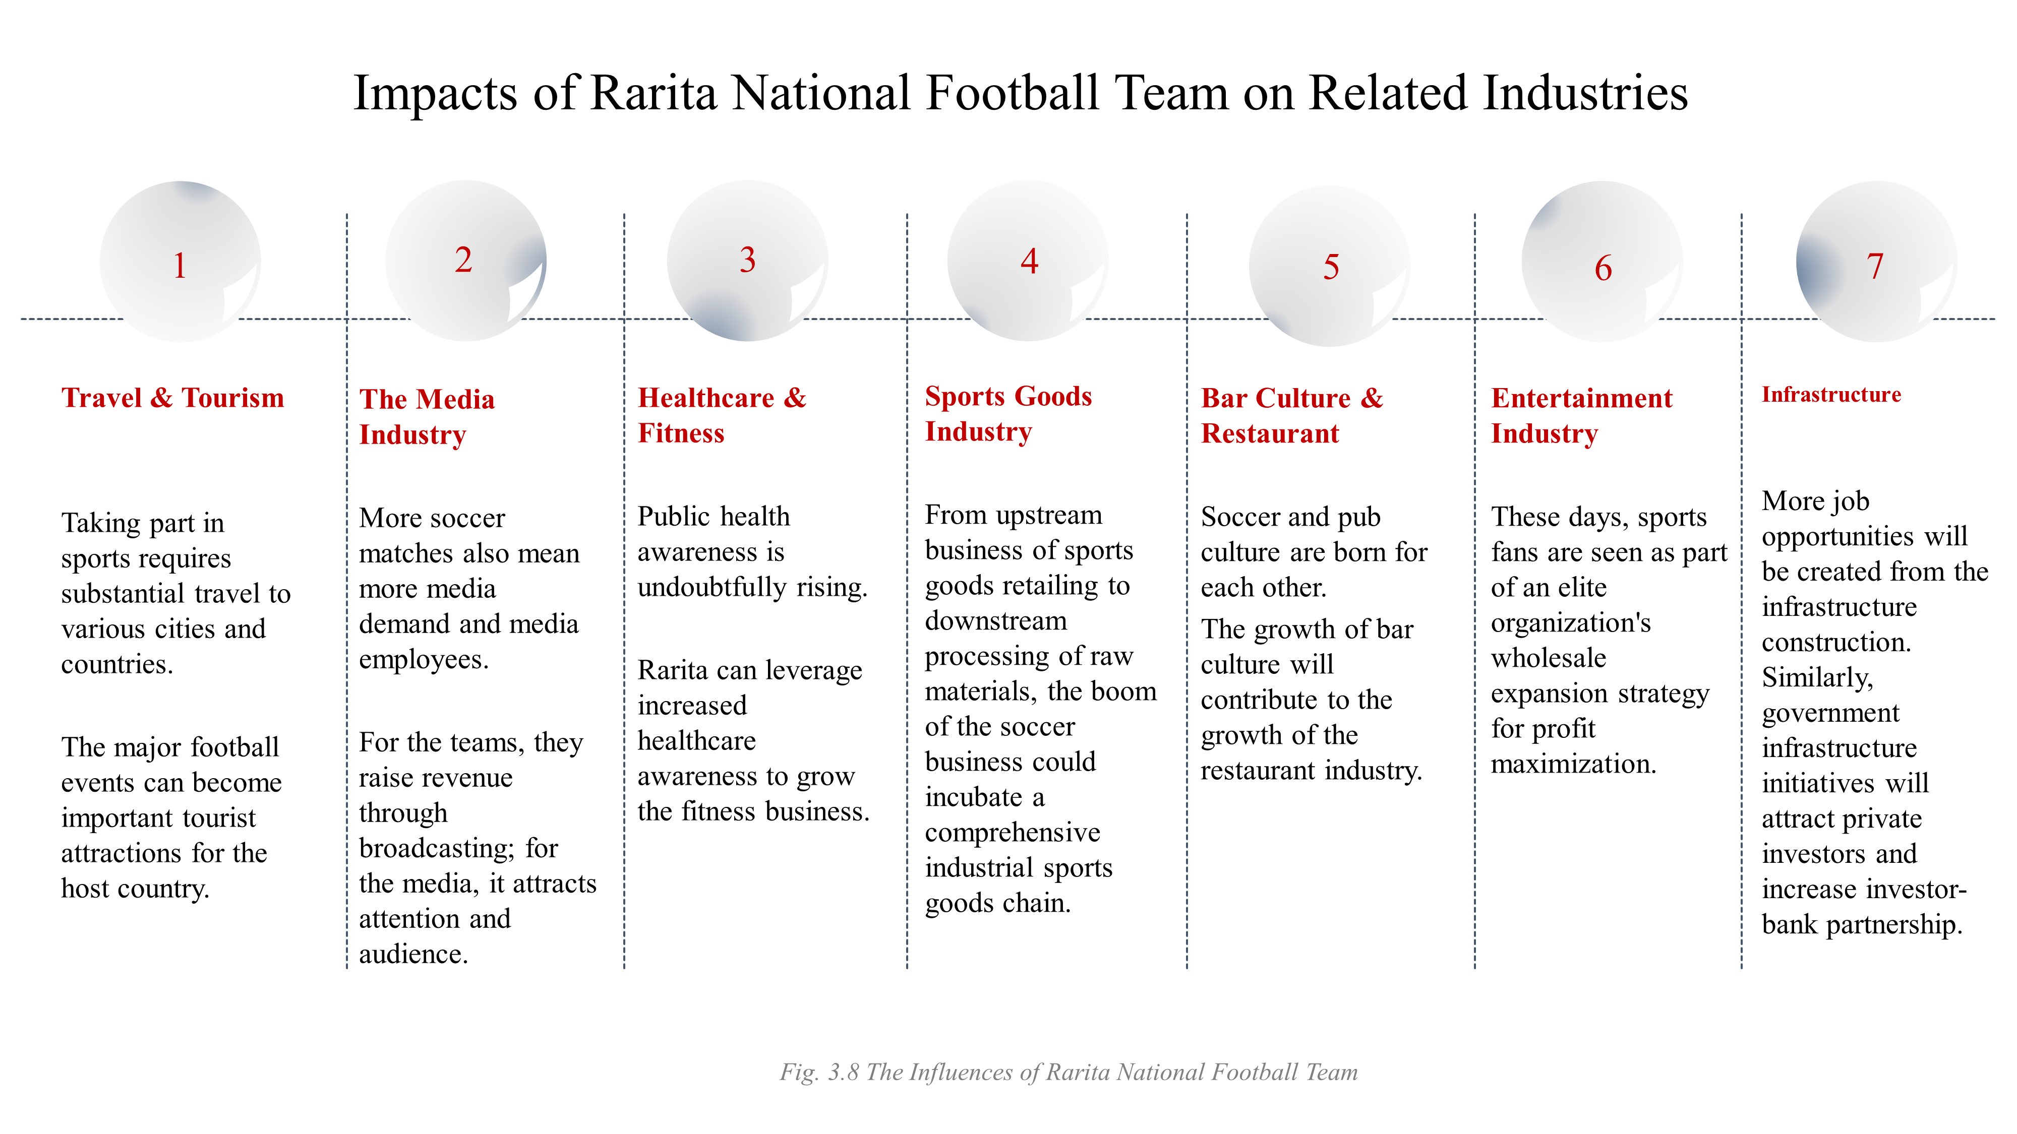

The build-up of a competitive soccer team in Rarita could bring economic breakthroughs for numerous related industries.

1. Travel & Tourism

Tourism and sports are inextricably linked.

1. The Media Industry

In modern culture, sports and media are inseparable.

1. Healthcare & Fitness

Sports is playing an increasingly active role in the modern life, especially for personal and public health.

1. Sports Goods Industry

Sporting equipment sales will be boosted by the success of the national soccer team.

1. Bar Culture

There is a growing body of evidence that the public house (or 'the pub') is a reliable place for study into football fandom behavior (Weed, M 2007).

1. Entertainment Industry

Consumers of sporting activities prefer remarkable talent (MacDonald, 1988).

1. Infrastructure

Rarita is expected to expand public transportation networks and large stadium constructions.

## Impact on Rarita provinces

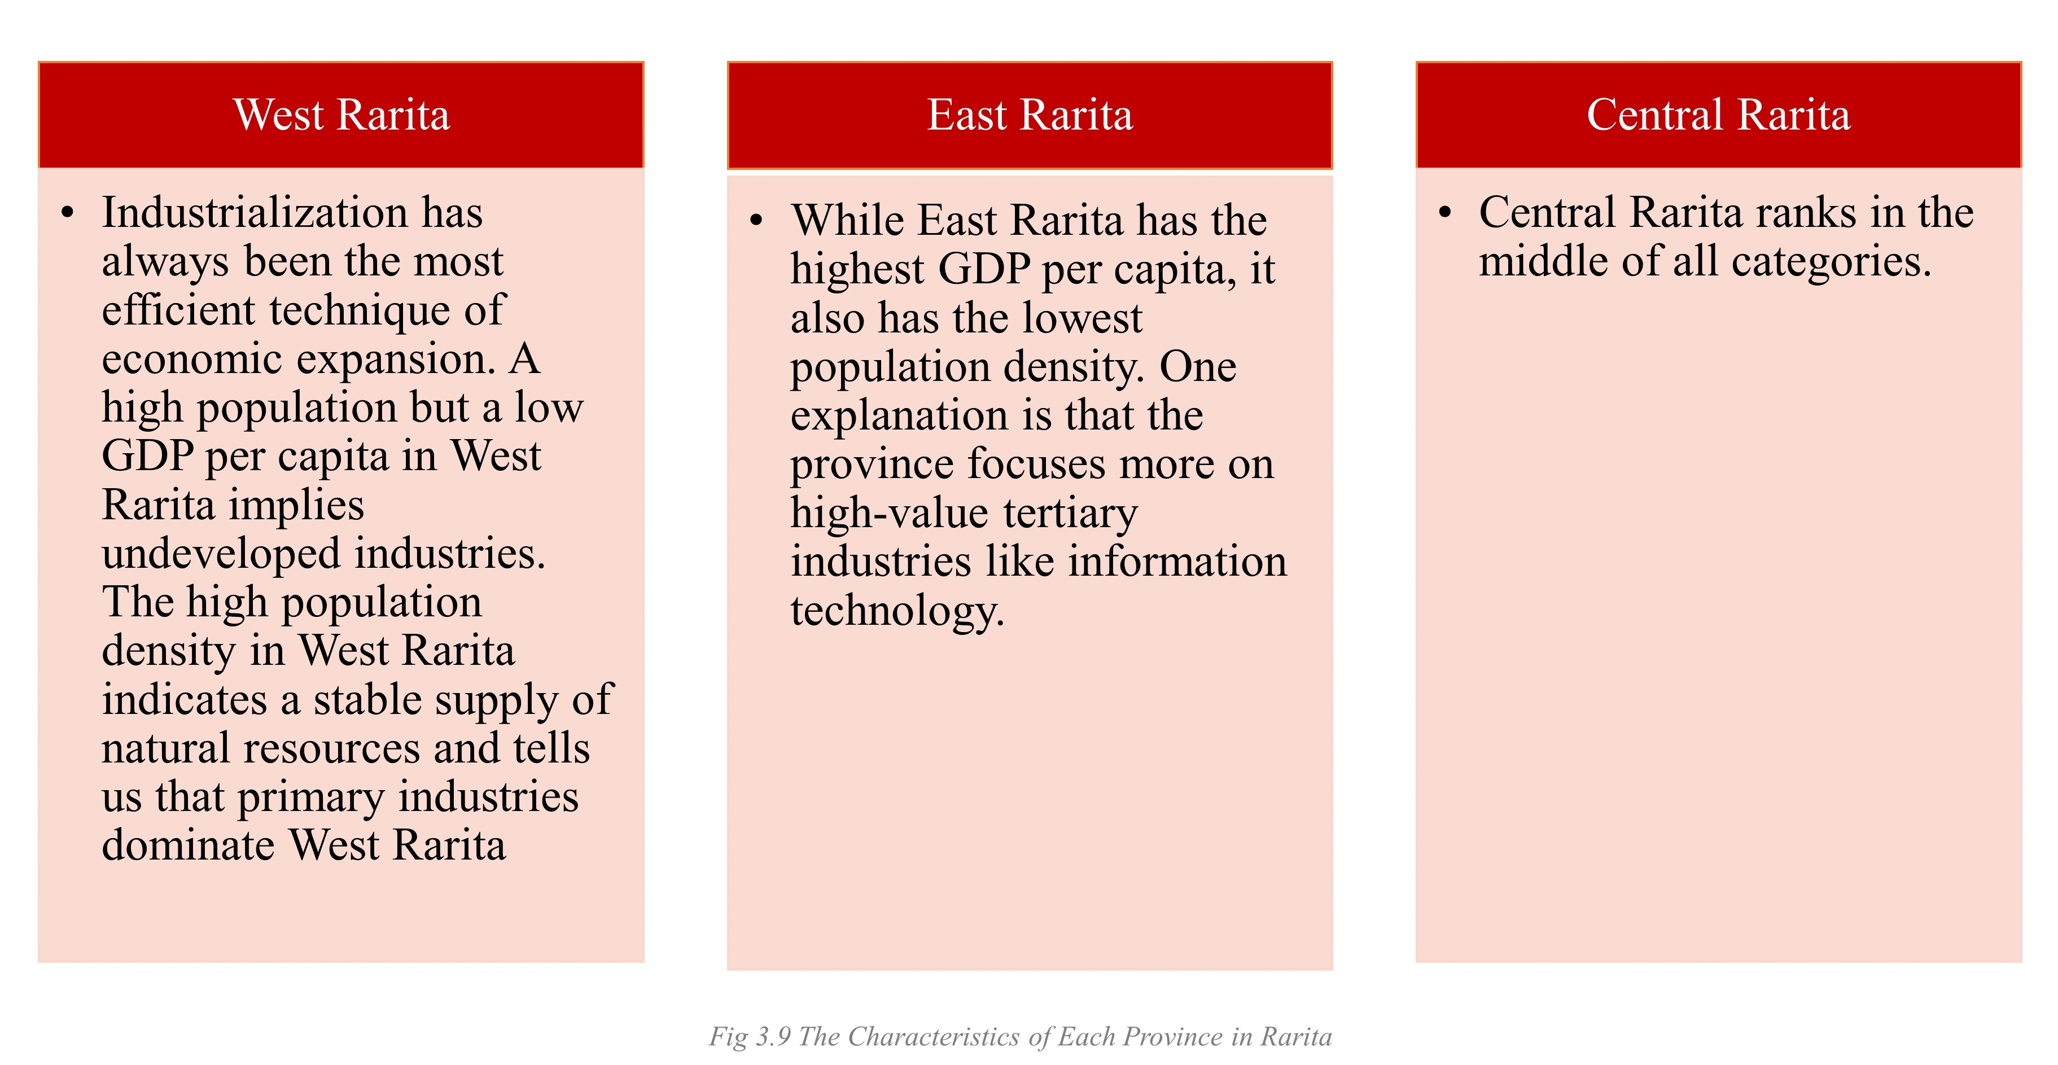

The program may move forward more smoothly in East Rarita since it is a wealthy province that will attract both public and private investment. The lack of taxation and government revenue in West Rarita may necessitate further government funding. However, West Rarita can open soccer schools and establish a youth program, taking advantages of its large population.

There are also ramifications for the entire country.

1. National Unity

Once the plan is successfully landed, the national enthusiasm for sports will skyrocket, especially for soccer. Sports will help people connect and support their country. More local sports organizations will be formed.

1. City Image

Along with national pride, there is also a sense of civic pride. There is a sense of community, of kinship, that complete strangers may bond simply by sharing a province and rooting for the same team.

1. Employment

A flourishing soccer industry will bring jobs far more than just the athletes—there are occupations involved with spectator sports such as coaches, referees, and agents.

# Implementation plan

## Team selection

With the KNN algorithm, selecting on key performance indices and considering other related factors, 17 top performers of non-goalkeepers and 2 top performers of goalkeepers to form a nineteen-people national soccer team for Rarita. H. Francisco (the elder player) will stay with the national team for the first five years until 2026 and C. Medina (the younger player) will join the national team from 2027 onward.

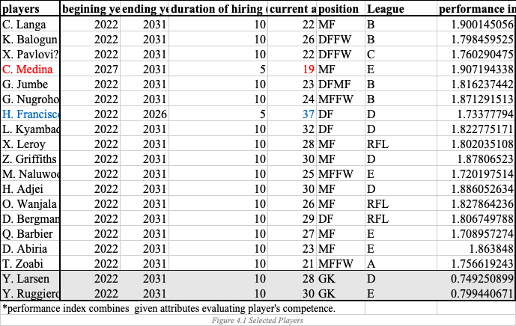

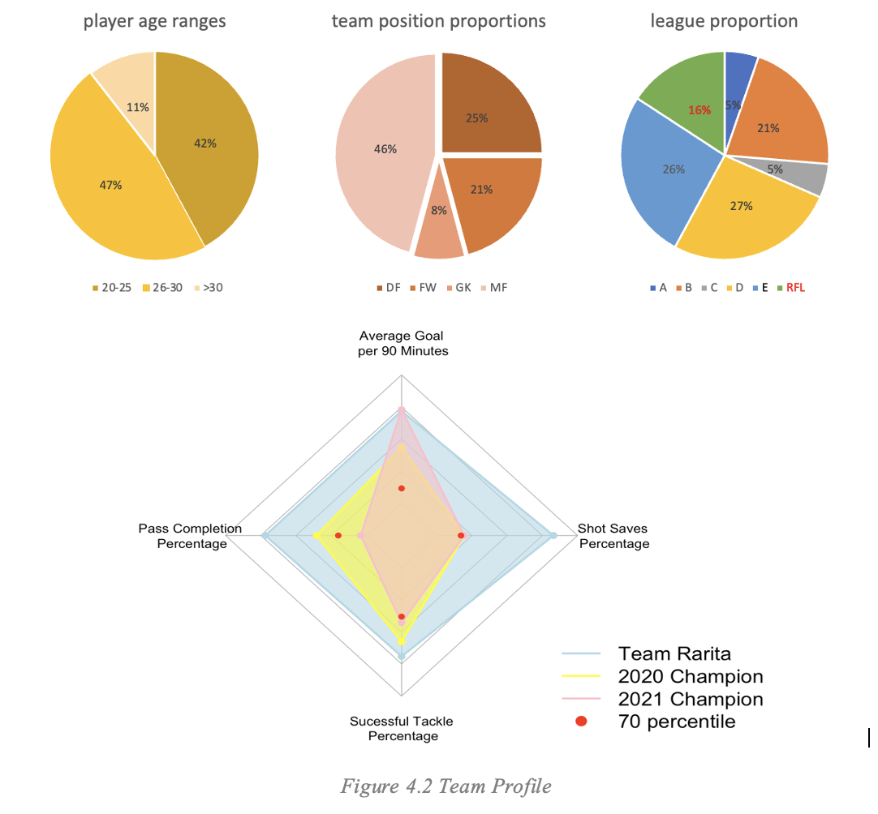

## Players' Salary Cost

One of the major expenses of running a national soccer team is the players' salary. To estimate salaries, inflation rates and salary increasing rates are applied with reasonable judgements.

$Year y Annual Salary=\sum_{i=1}^{19}{s_{i,2021}*{\left[\left(1+r\right)*\left(1+g_{i}\right)\right]}^{y-2021}}$,

where $s_{i,2021}$ is the 2021 salary for player i; $r$ is the constant inflation rate; $g_{i}$ is the salary increase rate for player $i, i=1, 2, …, 19$; $y$ is year, $y=2022, 2023,…, 2031.$

Scenario testing is implemented for player salary costs.

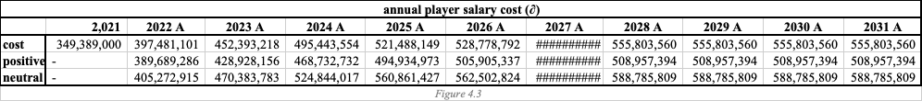

## Sources of Revenue

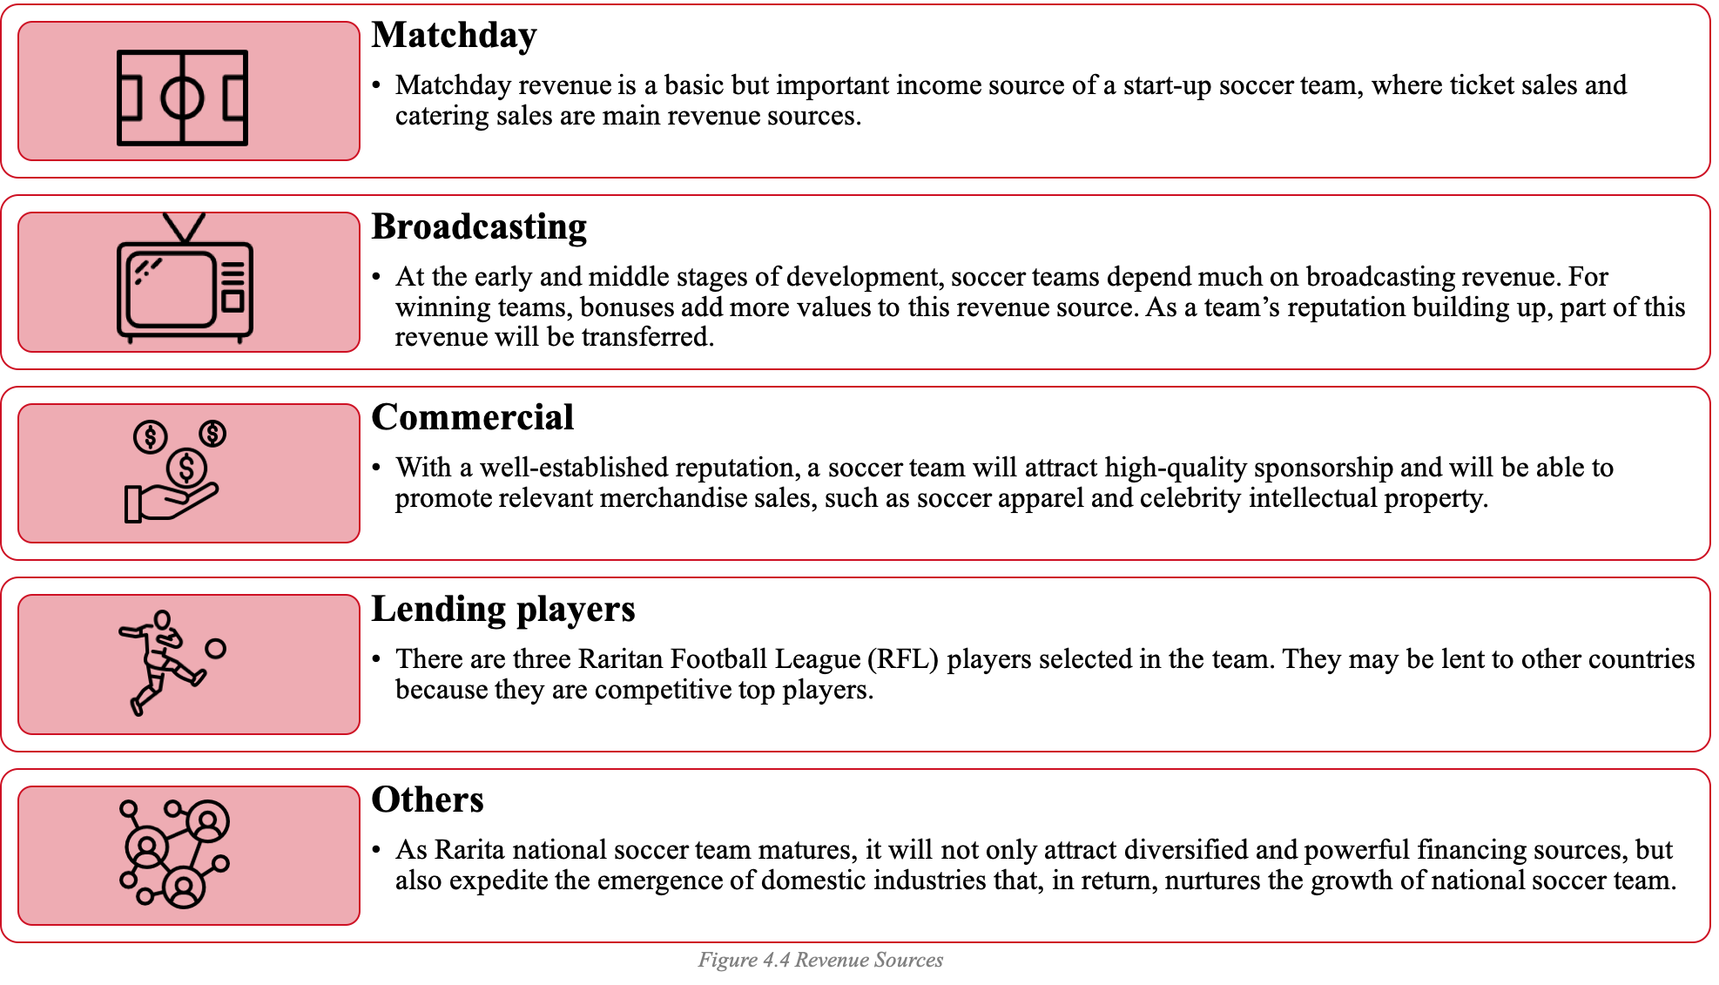

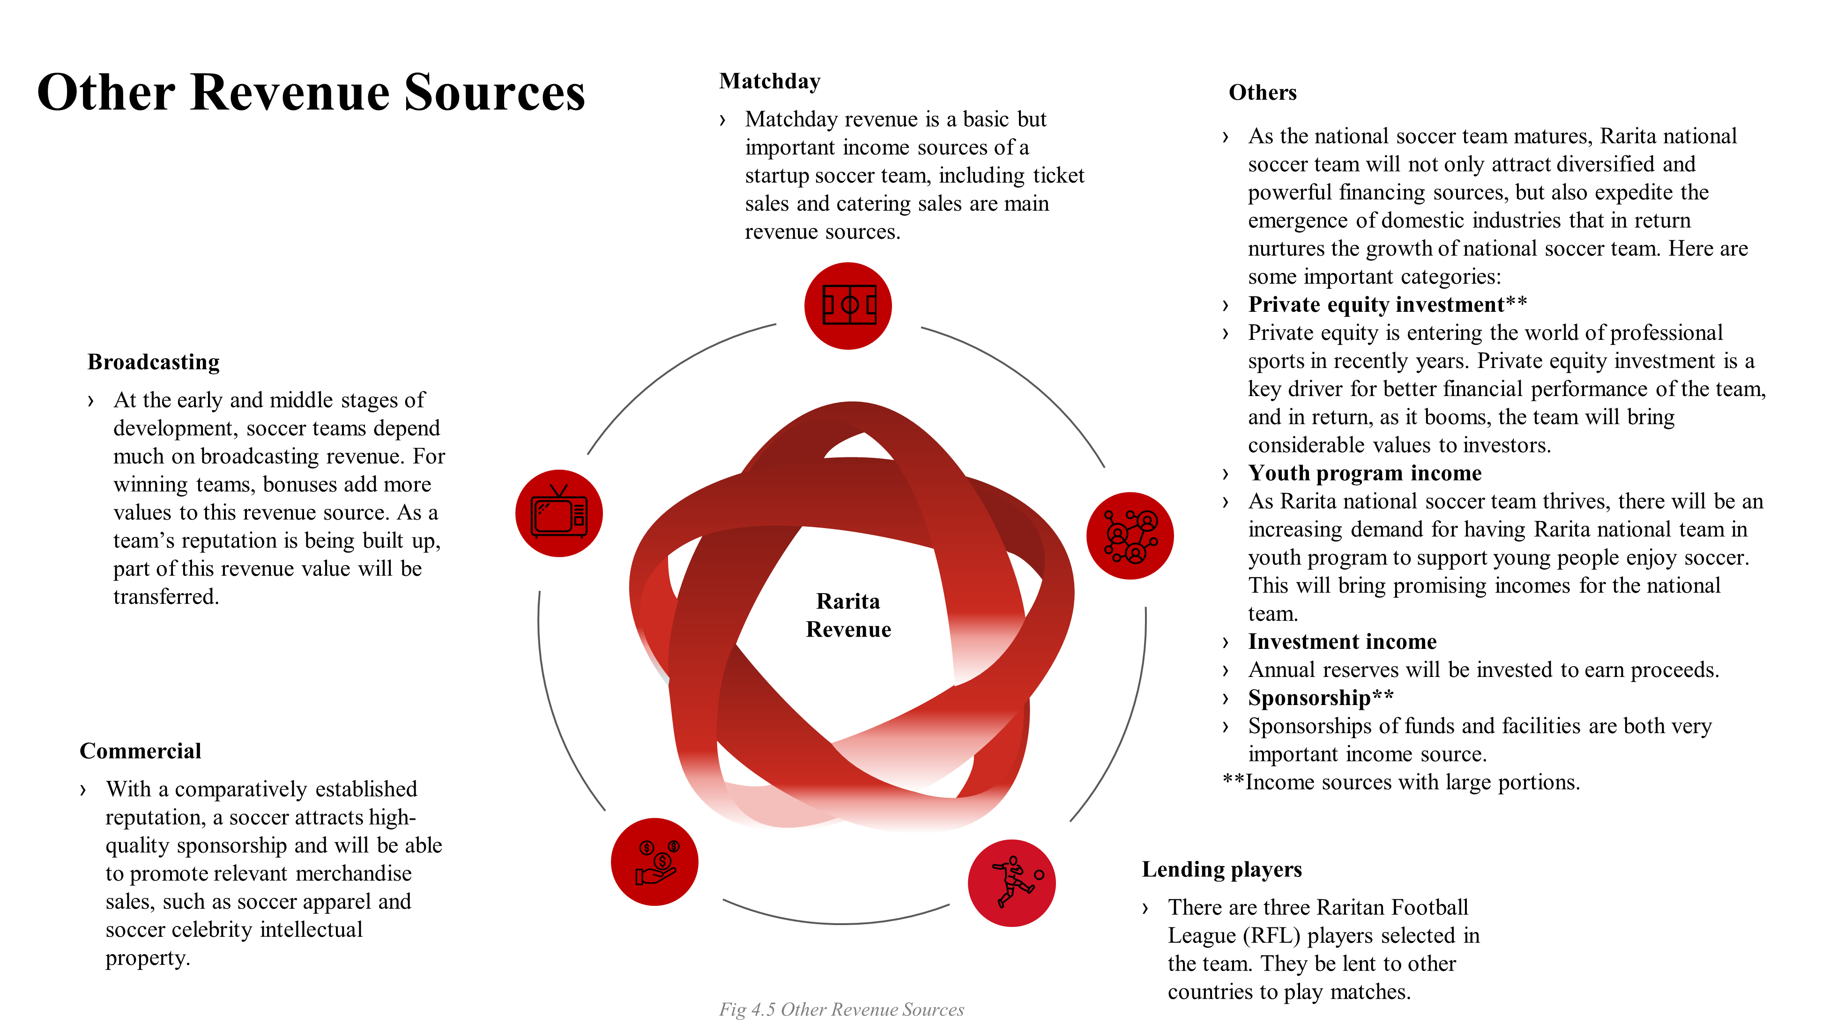

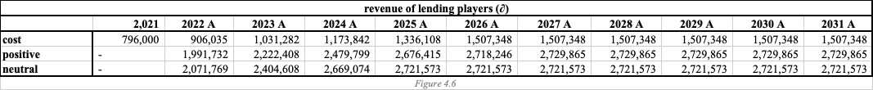

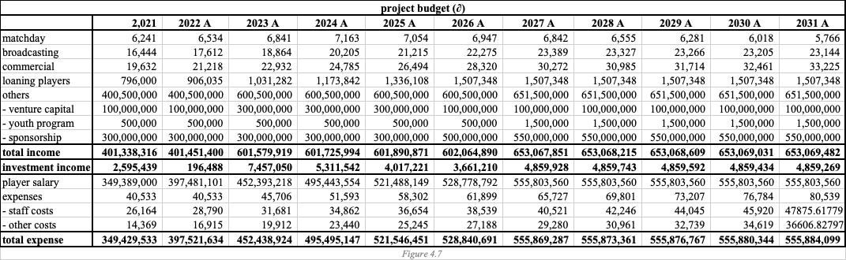

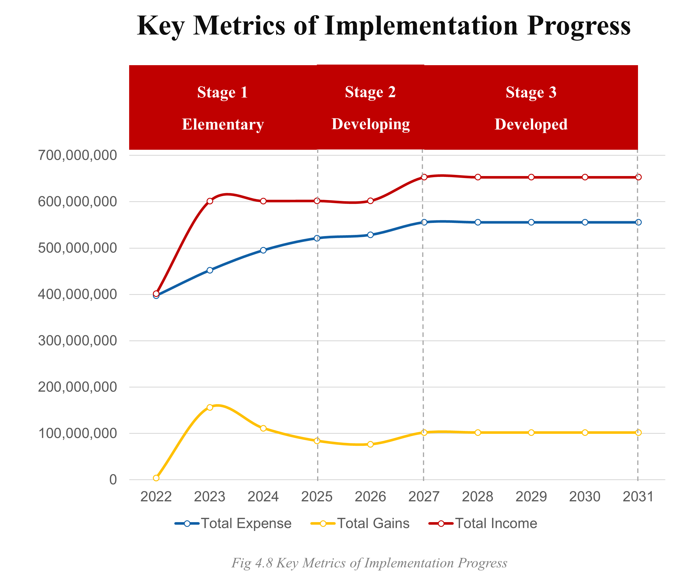

# Assumptions

**Team selection**

1. We assume that competitive teams consist of players with similar performance and skills.
2. We assume that a goalkeeper’s value is independent of passing, shooting and defense skills.
3. We assume that all players will perform at the same level as the average of the previous 2 years.
4. All league players are free agents (able to sign contracts with Rarita immediately).
5. In player data, player ages are as of 2018-2020, not 2022. Analysis are performed with ages as of 2022.

**Economic impact**

1. The inflation rate at Rarita is around 3% in the next 10 years.
2. The newcomers who ranked in 2021 tournament award, which are Djipines, Eastern Sleboube, Galamily and Giumle Lizeibon, their country's team was founded within the previous 5 years. That means, their national team were founded after Year 2016.
3. Nation teams are grouped in 3 groups, grouping by their 2021 tournament ranking, audience attendance level and number of social media followers.
4. The duration of invested fixed income securities is 5 years.
5. Soccer gambling is legal in Rarita.

**Risk analysis**

1. It is assumed that the risk factors follow normal distributions.
2. We assume that Team Rarita has a long investment horizon, and the management fee is assumed to be 0.05% each year by industry standard, given its assets under management.
3. The medical insurance is purchased for each player in the team and renewed each year to prevent injuries.
4. Team Rarita hires a public relation specialist in case of a public crisis for reputational considerations.
5. Team Rarita hires a legal consultant to ensure it signs lawful contracts with stakeholders.

**Data Limitation**

1. Only 2 years of data is given, making prediction of player’s future difficult.
2. Some of the player attributes have negative values, which does not make sense in real life and there in no explanation provided.
3. There are a lot of missing data, which impacts the integrity of the prediction.

# Risk & Sensitivity Analysis

## Risk identification & Mitigation

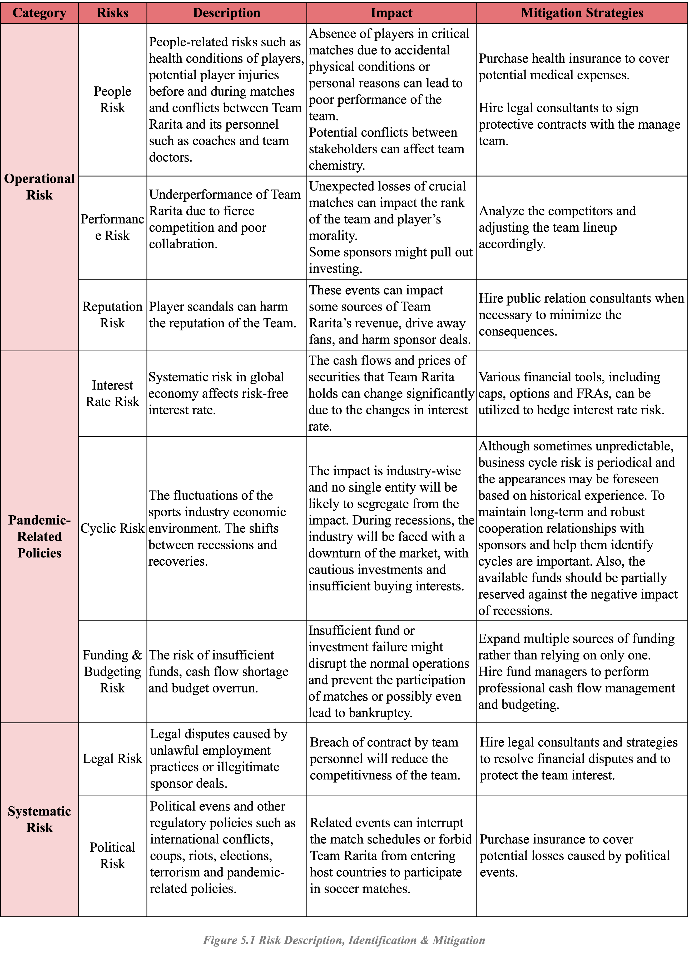The potential risk involving the launch of Rarita’s national soccer team can be classified into 3 major risk categories: systematic risk, operational risk, and financial risk.

A probability-severity coordinate diagram of all potential risks is created to display the rank and priority of risk factors based on their likelihood of occurring and severity of consequences if occurred.

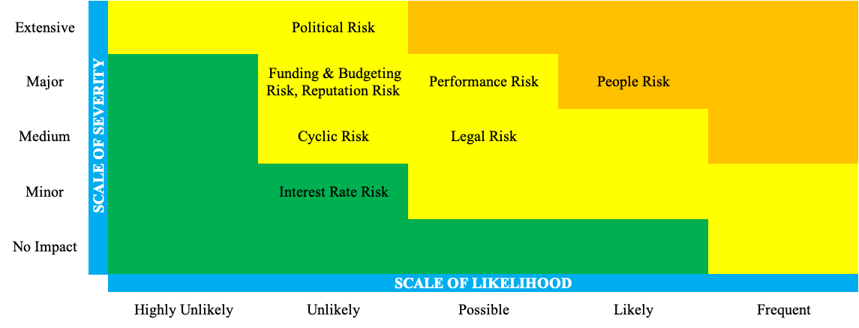

*Figure 5.2 Probability-severity coordinate diagram*

The probability of political events is low, but they can cause extensive consequences once occurred such as match deferrals or suspension. People risk is one of the most dynamic and unpredictable factors in businesses, especially in physically intensive sports. Interest rate risk can be hedged using financial tools such as options.

## Quantitative Risk Management

We apply quantitative tools and scenario analysis to estimate the potential expenses and losses, including Monte Carlo analysis.

Each risk factor follows the normal distribution. Scenario testing is performed on the sum of the potential loss. Repeating the calculation 500 times, we obtain the probability that one particular loss amount occurs. An emergency fund of 1 to 1.4 million ∂ could cover most of the cases.

## Revenue Sensitivity Analysis

We selected our assumptions described above through careful research and actuarial judgement. However, there may be potential fluctuations. We perform a sensitivity analysis to see how results would be affected by varying assumptions.

One key assumption is that inflation rate is around 3%. If inflation rate changes, the total revenue projection and total expense projection would be highly affected. A 1% increase in inflation rate would lead to a 1.81% increase in total 10-year revenue.



*Figure 5.3 Revenue projection at inflation rate 3%, 5%, 7% and 9% respectively*



*Figure 5.4 Chart Revenue projection at inflation rate 3%, 5%, 7% and 9% respectively*

## Investment Portfolio Sensitivity Analysis

One key assumption is that the interest rate is 0.5% (US federal fund rate) and Return-on-Investment ranges from 5% ~ 5.5%. Interest rates and fixed-income asset prices are inversely correlated. A 1% change in interest rate could result in a 5% change in portfolio value of soccer team.



$$\% Change in Bond Price= -Duration*\% Change in Interest Rate$$

*Figure 5.5 Impact of Interest Rate Change on Investment Portfolio Value Proposed by Soccer Team (All values are expressed in Rarita Doubloons)*

# Data & Data Limitations

1. Only 2 years of the player data is given, making prediction of players’ future performance difficult.
2. Some of the player attributes have negative values, which does not make sense in real life and there in no explanation provided.
3. There are a lot of missing data, which impacts the integrity of the prediction.
4. In economic data set, we lack information about the time when each nation’s soccer team was set up, which prevents us from taking a nation’s individual practices into account.
5. In risk section, the data on losses and expenses brought by risk factors is limited. The only data provided is the spot rate of Rarita within the past few years.
6. The risk factors may not follow normal distribution in reality, but we have limited data on estimating the loss distribution.

# Appendix

## R Code

library(readxl)

library(dplyr)

#Load data

file_path <- "2022-student-research-case-study-player-data_modified.xlsx"

#read in tables

LeagueShoot <- read_excel(file_path, sheet = "League Shooting", skip = 11,col_names =T, na = "N/A")

LeaguePass <- read_excel(file_path, sheet = "League Passing", skip = 11,col_names =T)

LeagueDefense <- read_excel(file_path, sheet = "League Defense", skip = 11,col_names =T, na = "N/A")

TournShoot <- read_excel(file_path, sheet = "Tournament Shooting", skip = 11,col_names =T, na = "N/A")

TournPass <- read_excel(file_path, sheet = "Tournament Passing", skip = 11,col_names =T)

TournDefense <- read_excel(file_path, sheet = "Tournament Defense", skip = 11,col_names =T, na = "N/A")

tables <- list("LeagueShoot" = LeagueShoot, "LeaguePass" = LeaguePass, "LeagueDefense" = LeagueDefense, "TournShoot" = TournShoot, "TournPass" = TournPass, "TournDefense" = TournDefense)

#calculate %s

LeagueShoot$'Gls' <- LeagueShoot$'Gls'/LeagueShoot$'90s'

LeagueShoot$'Performance PKatt' <- LeagueShoot$'Performance PKatt'/LeagueShoot$'Performance PK'

TournShoot$'Gls' <- TournShoot$Gls/TournShoot$'90s'

TournShoot$'Performance PKatt' <- TournShoot$'Performance PKatt'/TournShoot$'Performance PK'

LeagueDefense$'Tackles TklW' <- LeagueDefense$'Tackles TklW'/LeagueDefense$'Tackles Tkl'

LeagueDefense$'Tackles Tkl' <- LeagueDefense$'Tackles Tkl'/LeagueDefense$'90s'

LeagueDefense$'Vs Dribbles Past' <- LeagueDefense$'Vs Dribbles Past'/LeagueDefense$'90s'

LeagueDefense$'Pressures Succ' <- LeagueDefense$'Pressures Succ'/LeagueDefense$'Pressures Press'

LeagueDefense$'Blocks Blocks' <- LeagueDefense$'Blocks Blocks'/LeagueDefense$'90s'

LeagueDefense$'Int' <- LeagueDefense$'Int'/LeagueDefense$'90s'

LeagueDefense$'Clr' <- LeagueDefense$'Clr'/LeagueDefense$'90s'

LeagueDefense$'Err' <- LeagueDefense$'Err'/LeagueDefense$'90s'

TournDefense$'Tackles TklW' <- TournDefense$'Tackles TklW'/TournDefense$'Tackles Tkl'

TournDefense$'Tackles Tkl' <- TournDefense$'Tackles Tkl'/TournDefense$'90s'

TournDefense$'Vs Dribbles Past' <- TournDefense$'Vs Dribbles Past'/TournDefense$'90s'

TournDefense$'Pressures Succ' <- TournDefense$'Pressures Succ'/TournDefense$'Pressures Press'

TournDefense$'Blocks Blocks' <- TournDefense$'Blocks Blocks'/TournDefense$'90s'

TournDefense$'Int' <- TournDefense$'Int'/TournDefense$'90s'

TournDefense$'Clr' <- TournDefense$'Clr'/TournDefense$'90s'

TournDefense$'Err' <- TournDefense$'Err'/TournDefense$'90s'

#fix infinity & -infinity %

LeagueShoot$'Gls'[which(LeagueShoot$'Gls' == Inf | LeagueShoot$'Gls' == -Inf)] <- 0

TournShoot$'Gls'[which(TournShoot$'Gls' == Inf | TournShoot$'Gls' == -Inf)] <- 0

LeagueShoot$'Performance PKatt'[which(LeagueShoot$'Performance PKatt' == Inf | LeagueShoot$'Performance PKatt' == -Inf)] <- 0

TournShoot$'Performance PKatt'[which(TournShoot$'Performance PKatt' == Inf | TournShoot$'Performance PKatt' == -Inf)] <- 0

LeagueDefense$'Tackles TklW'[which(LeagueDefense$'Tackles TklW' == Inf | LeagueDefense$'Tackles TklW' == -Inf)] <- 0

TournDefense$'Tackles TklW'[which(TournDefense$'Tackles TklW' == Inf | TournDefense$'Tackles TklW' == -Inf)] <- 0

LeagueDefense$'Tackles Tkl'[which(LeagueDefense$'Tackles Tkl' == Inf | LeagueDefense$'Tackles Tkl' == -Inf)] <- 0

TournDefense$'Tackles Tkl'[which(TournDefense$'Tackles Tkl' == Inf | TournDefense$'Tackles Tkl' == -Inf)] <- 0

LeagueDefense$'Vs Dribbles Past'[which(LeagueDefense$'Vs Dribbles Past' == Inf | LeagueDefense$'Vs Dribbles Past' == -Inf)] <- 0

TournDefense$'Vs Dribbles Past'[which(TournDefense$'Vs Dribbles Past' == Inf | TournDefense$'Vs Dribbles Past' == -Inf)] <- 0

LeagueDefense$'Pressures Succ'[which(LeagueDefense$'Pressures Succ' == Inf | LeagueDefense$'Pressures Succ' == -Inf)] <- 0

TournDefense$'Pressures Succ'[which(TournDefense$'Pressures Succ' == Inf | TournDefense$'Pressures Succ' == -Inf)] <- 0

LeagueDefense$'Blocks Blocks'[which(LeagueDefense$'Blocks Blocks' == Inf | LeagueDefense$'Blocks Blocks' == -Inf)] <- 0

TournDefense$'Blocks Blocks'[which(TournDefense$'Blocks Blocks' == Inf | TournDefense$'Blocks Blocks' == -Inf)] <- 0

LeagueDefense$'Int'[which(LeagueDefense$'Int' == Inf | LeagueDefense$'Int' == -Inf)] <- 0

TournDefense$'Int'[which(TournDefense$'Int' == Inf | TournDefense$'Int' == -Inf)] <- 0

LeagueDefense$'Clr'[which(LeagueDefense$'Clr' == Inf | LeagueDefense$'Clr' == -Inf)] <- 0

TournDefense$'Clr'[which(TournDefense$'Clr' == Inf | TournDefense$'Clr' == -Inf)] <- 0

LeagueDefense$'Err'[which(LeagueDefense$'Err' == Inf | LeagueDefense$'Err' == -Inf)] <- 0

TournDefense$'Err'[which(TournDefense$'Err' == Inf | TournDefense$'Err' == -Inf)] <- 0

#Defender analysis

LDefense.NAattributes <- c(2, 3, 4, 6, 31, 32)

TDefense.NAattributes <- c(2, 3, 5, 30, 31)

LeagueDefense.data <- LeagueDefense[which(LeagueDefense$Pos != "GK"), -LDefense.NAattributes]

TournDefense.data <- TournDefense[which(TournDefense$Pos != "GK"), -TDefense.NAattributes]

#Fill in missing data

for(attribute in 1:ncol(LeagueDefense.data)){

if(sum(is.na(LeagueDefense.data[,attribute]))) {

# find out the columns with missing values

print(paste(sum(is.na(LeagueDefense.data[,attribute])), "missing values in League Defense.", attribute))

# fill the missing values with 0

LeagueDefense.data[is.na(LeagueDefense.data[, attribute]), attribute] <- 0

}

}

for(attribute in 1:ncol(TournDefense.data)){

if(sum(is.na(TournDefense.data[,attribute]))) {

# find out the columns with missing values

print(paste(sum(is.na(TournDefense.data[,attribute])), "missing values in Tournament Defense.", attribute))

# fill the missing values with 0

TournDefense.data[is.na(TournDefense.data[, attribute]), attribute] <- 0

}

}

#Group rows by player

#Use the average value for each attribute

LeagueDefense.groupByPlayer <- LeagueDefense.data %>%

group_by(Player) %>%

summarise_all(mean)

TournDefense.groupByPlayer <- TournDefense.data %>%

group_by(Player) %>%

summarise_all(mean)

#Passing analysis

#Selecting variants

attributes: 90s, xA, A-xA, KP, Total Cmp%

LPass.NAattributes <- c(2, 3, 4, 6, 30, 31)

TPass.NAattributes <- c(2, 3, 5, 29, 30)

LeaguePass.data <- LeaguePass[which(LeaguePass$Pos != "GK"), -LPass.NAattributes]

TournPass.data <- TournPass[which(TournPass$Pos != "GK"), -TPass.NAattributes]

# Fill in missing data

# find out the columns with missing values

for(attribute in 1:ncol(LeaguePass.data)){

if(sum(is.na(LeaguePass.data[,attribute]))) {

# find out the columns with missing values

print(paste(sum(is.na(LeaguePass.data[,attribute])), "missing values in League Passing.", attribute))

# fill the missing values with 0

LeaguePass.data[is.na(LeaguePass.data[, attribute]), attribute] <- 0

}

}

for(attribute in 1:ncol(TournPass.data)){

if(sum(is.na(TournPass.data[,attribute]))) {

# find out the columns with missing values

print(paste(sum(is.na(TournPass.data[,attribute])), "missing values in Tournament Passing.", attribute))

# fill the missing values with 0

TournPass.data[is.na(TournPass.data[, attribute]), attribute] <- 0

}

}

#Group rows by player

#Use the average value for each attribute

library(dplyr)

LeaguePass.groupByPlayer <- LeaguePass.data %>%

group_by(Player) %>%

summarise_all(mean)

TournPass.groupByPlayer <- TournPass.data %>%

group_by(Player) %>%

summarise_all(mean)

#Shooting analysis

#Selecting variants

LShoot.NAattributes <- c(2, 3, 4, 6, 17, 20, 21, 22, 23, 24, 25, 26)

TShoot.NAattributes <- c(2, 3, 5, 18, 19)

LeagueShoot.data <- LeagueShoot[which(LeagueShoot$Pos != "GK"), -LShoot.NAattributes]

TournShoot.data <- TournShoot[which(TournShoot$Pos != "GK"), -TShoot.NAattributes]

# find out the columns with missing values

for(attribute in 1:ncol(LeagueShoot.data)){

if(sum(is.na(LeagueShoot.data[,attribute]))) {

print(paste(sum(is.na(LeagueShoot.data[,attribute])), "missing values in League Forward.", attribute))

LeagueShoot.data[is.na(LeagueShoot.data[, attribute]), attribute] <- 0

}

}

for(attribute in 1:ncol(TournShoot.data)){

if(sum(is.na(TournShoot.data[,attribute]))) {

print(paste(sum(is.na(TournShoot.data[,attribute])), "missing values in Tournament Forward.", attribute))

TournShoot.data[is.na(TournShoot.data[, attribute]), attribute] <- 0

}

}

#Group rows by player

#Use the average value for each attribute

LeagueShoot.groupByPlayer <- LeagueShoot.data %>%

group_by(Player) %>%

summarise_all(mean)

TournShoot.groupByPlayer <- TournShoot.data %>%

group_by(Player) %>%

summarise_all(mean)

#Note: All players in tournament does not occur more than twice

for(player in unique(TournDefense.data$Player)) {

s <- length(which(TournDefense.data$Player == player))

if(s > 2) print(s)

}

for(player in unique(TournPass.data$Player)) {

s <- length(which(TournPass.data$Player == player))

if(s > 2) print(s)

}

for(player in unique(TournShoot.data$Player)) {

s <- length(which(TournShoot.data$Player == player))

if(s > 2) print(s)

}

#join tables

tables.gbp <- list("ls.gbp" = LeagueShoot.groupByPlayer, "ts.gbp" = TournShoot.groupByPlayer, "ld,gbp" = LeagueDefense.groupByPlayer, "td.gbp" = TournDefense.groupByPlayer, "lp.gbp" = LeaguePass.groupByPlayer, "tp.gbp" = TournPass.groupByPlayer)

League.tables <- list(LeagueShoot.groupByPlayer, LeaguePass.groupByPlayer, LeagueDefense.groupByPlayer)

Tourn.tables <- list(TournShoot.groupByPlayer, TournPass.groupByPlayer, TournDefense.groupByPlayer)

League.JoinedTable <- inner_join(inner_join(League.tables[[1]], League.tables[[2]], by="Player"), League.tables[[3]], by="Player")

Tourn.JoinedTable <- inner_join(inner_join(Tourn.tables[[1]], Tourn.tables[[2]], by="Player"), Tourn.tables[[3]], by="Player")

# find the average playing time

League.JoinedTable$"90s" <- (League.JoinedTable$"90s" + League.JoinedTable$"90s.x" + League.JoinedTable$"90s.y")/3

Tourn.JoinedTable$"90s" <- (Tourn.JoinedTable$"90s" + Tourn.JoinedTable$"90s.x" + Tourn.JoinedTable$"90s.y")/3

League.JoinedTable <- League.JoinedTable[ , !(names(League.JoinedTable) %in% c("90s.x", "90s.y"))]

Tourn.JoinedTable <- Tourn.JoinedTable[ , !(names(Tourn.JoinedTable) %in% c("90s.x", "90s.y"))]

Tourn.JoinedTable.ranked <- Tourn.JoinedTable[which(!is.na(Tourn.JoinedTable$`nation rank`)),]

nrow(League.JoinedTable)

nrow(Tourn.JoinedTable)

#Normalize Data

norm <-function(x) {

upper = quantile(x, .98)

lower = quantile(x, .02)

x_norm <- (x-lower)/(upper-lower)

x_norm[which(x_norm > 1)] = 1

x_norm[which(x_norm < 0)] = 0

x_norm

}

playerIndex <- which(colnames(Tourn.JoinedTable.ranked) == "Player")

rankIndex <- which(colnames(Tourn.JoinedTable.ranked) == "nation rank")

Tourn_norm <- as.data.frame(lapply(Tourn.JoinedTable.ranked[,-c(playerIndex,rankIndex)], norm))

LeagePlayerIndex <- which(colnames(League.JoinedTable) == "Player")

League_norm <- as.data.frame(lapply(League.JoinedTable[,-LeagePlayerIndex], norm))

#Principle Component Analysis

#decide how many components to use

eigenvalues <- eigen(cor(League_norm))$values

eigenvaluesProp <- cumsum(eigenvalues)/sum(eigenvalues)

par(mfrow = c(1,2), cex = 0.8)

plot(eigenvalues, main = "Eigenvalues of the Correlation Matrix", sub = "Figure 2.1 Eigenvalues of the Correlation Matrix")

plot(eigenvaluesProp, xlab = "number of components", ylab = "proportion", main = "Proportion of Variation Included", sub = "Figure 2.2 Variation explained corresponding to the number of components used in PCA")

abline(h = 0.9, lty = 2, col = "red")

abline(v = 21, lty = 21, col = "red")

points(21, eigenvaluesProp[21], pch = 19, col = "red", cex = 0.95)

text(26, 0.85, col = "red", "(21, 0.9)")

#We'll choose 26 components to over 90% of the variation.

#check if the variance of different attributes are large

apply(Tourn_norm, 2, var)

plot(apply(Tourn_norm, 2, var))

#apply Principle Component Analysis

compNum <- 22

pca = prcomp(Tourn_norm, scale = T)

Tourn_norm.pca <- as.matrix(Tourn_norm) %*% as.matrix(pca$rotation[,1:compNum])

#run knn function

library(class)

k <- 18

error <- 9

TournRanks <- Tourn.JoinedTable.ranked$`nation rank`

pr <- knn.cv(Tourn_norm.pca,cl=TournRanks,k=k,use.all = TRUE)

accuracy <- sum(abs(as.numeric(pr) - as.numeric(TournRanks)) <= error) / length(pr)

accuracy

League_norm.pca <- as.matrix(League_norm) %*% as.matrix(pca$rotation[,1:compNum])

Target_category <- as.data.frame(Tourn.JoinedTable.ranked)[,rankIndex]

predRank <- knn(Tourn_norm.pca,League_norm.pca,cl=Target_category,k=k)

League.JoinedTable$"Pred Rank" <- predRank

table(predRank)

## Categorization of Countries for 3.3 impacts on GDP

The Developed Performance Cluster includes People's Land of Maneau, Nganion, and Southern Ristan; Developing Performance Cluster includes Sobianitedrucy, Quewenia, Esia, Mico, Bernepamar, Manlisgamncent, Greri Landmoslands, and Dosqaly; Elementary Performance Cluster includes Byasier Pujan, Xikong, Galamily, Nkasland Cronestan, Giumle Lizeibon, Djipines, Eastern Sleboube. (include in appendix)

In the Developed Performance Cluster, with the average annual growth rate is 0.69%, an increase in GDP per capita from ∂23,863 to ∂25,554 in ten years can be projected.

In the Developing Performance Cluster, with the average annual growth rate is 3.53%, an increase in GDP per capita from ∂23,864 to ∂33,758 in ten years can be projected.

In the Elementary Performance Cluster, with the average annual growth rate is 2.87%, an increase in GDP per capita from ∂23,864 to ∂31,659 in ten years can be projected.

In 2018, all countries had the highest GDP among the five-year period. Assuming all national teams were founded after 2016, the third year after forming the team will have the greatest influence on the total economy.

# Reference

Weil, D. (2021, August 30). *Private equity has definitively entered the world of professional sports: Here's what comes next.* Institutional Investor. Retrieved from: https://www.institutionalinvestor.com/article/b1tckcs3y46zw4/Private-Equity-Has-Definitively-Entered-the-World-of-Professional-Sports-Here-s-What-Comes-Next

Weed, M (2007). *The pub as a virtual football fandom venue: An alternative to ‘being there’?* Soccer & Society 8(2–3): 399–414. Retrieved from: https://www.tandfonline.com/doi/full/10.1080/14660970701224665

MacDonald, G. M. (1988). *The Economics of Rising Stars.* The American Economic Review, 78(1), 155–166. Retrieved from: [https://www.jstor.org/stable/1814704?seq=](https://www.jstor.org/stable/1814704?seq=1)1

Team, T. I. (2022, January 7). *How do recessions impact businesses?* Investopedia. Retrieved from: https://www.investopedia.com/articles/economics/08/recession-affecting-business.asp